Burien Client Recommendations
Green Team
Darci
Kyle
William Schnaith
Dylan
Edith
Chris

Executive Summary

In response to the evolving threat landscape, our team conducted 33 comprehensive investigations focusing on key areas of concern within the Burien municipal network. These investigations delved into data movement patterns, the origin of “North/South” network traffic, alert signatures of well-known malware, indicators of malicious use of legitimate platforms, and municipal network user behavior. Our analysis revealed primary domains of observed or assumed malicious traffic, notably encompassing web scanning, file sharing, simulated phishing campaigns under the guise of enterprise security training, and initial entry attempts through vulnerability enumeration and exploitation. Based on our findings, we have formulated these formal recommendations aimed at bolstering the resilience and efficacy of the network's security posture. These recommendations are detailed further in the subsequent sections of this report, providing actionable insights to enhance threat mitigation strategies and safeguard critical infrastructure.

The ConnectWise ScreenConnect Auth Bypass
CVE-2024-1709

- ConnectWise ScreenConnect initial entry vectors were observed multiple times
- Mass exploitation attempts have been observed since public disclosure
- Malicious follow-on actions post-exploit include ransomware and extortion schemes

Summary and Recommendation:

ConnectWise ScreenConnect's recent vulnerabilities (CVE-2024-1709 and CVE-2024-1708) have led to widespread exploitation, prompting urgent action from both ConnectWise and security experts. Security vendors such as Mandiant and Sophos X-Ops emphasize immediate isolation and patching of vulnerable instances. Given the severity and widespread exploitation of these vulnerabilities, it is imperative that network administration teams take proactive measures to safeguard their infrastructure. Firstly, they should conduct a comprehensive inventory to identify all instances of ConnectWise ScreenConnect within their network environment. Next, immediate patching and upgrading to the latest version (v23.9.10.8817 or v22.4) should be prioritized to mitigate the risks associated with CVE-2024-1709 and CVE-2024-1708. Additionally, the team should implement robust monitoring and detection mechanisms to swiftly identify any suspicious activities indicative of compromise. Regular vulnerability assessments and penetration testing can further strengthen their defense posture against emerging threats.

Chains of communication from IPs on a known malicious Subnet
-Tickets 0005561 and 0005966 show instances of communication to and from two different malicious IPs that are on the same compromised subnet
-For ticket 0005966, we started seeing traffic on 1/13/2024 and stopped seeing events on 3/5/2024 for about a week (assumed to be due to the fact that it was blocked)
-As of 3/14/2024, we’re receiving flow events from the IP still, there just seems to be no return traffic do to it being blocked

Summary and Recommendation:

This is an IP range that was flagged for having compromised hosts and therefore being malicious (specific hosts seen were 78.153.140.175 and 78.153.140.173). There were multiple alerts generated that they were in poor reputation IP groups. These alerts were also paired with alerts for “Request to Hidden Environment File”. These alerts were generated, which seems to signify traffic that shouldn’t be happening in a production environment. Yet, we were still getting flow events with bytes that went into the tens of thousands. While it seems that communication from the compromised IPs stopped on around 3/15/2024 (likely due to being blocked), I suggest that we ensure that the IPs are blocked for other clients that we’re responsible for monitoring and protecting. We also suggest implementing a method to block IPs sooner when they cause alerts for having a poor reputation. While there may be some cases that an IP might be associated with a poor reputation list for some reason when they shouldn’t, a vast majority of the time we should heed the warning and not allow traffic because in a production environment there's no reason that we should be taking the chance.
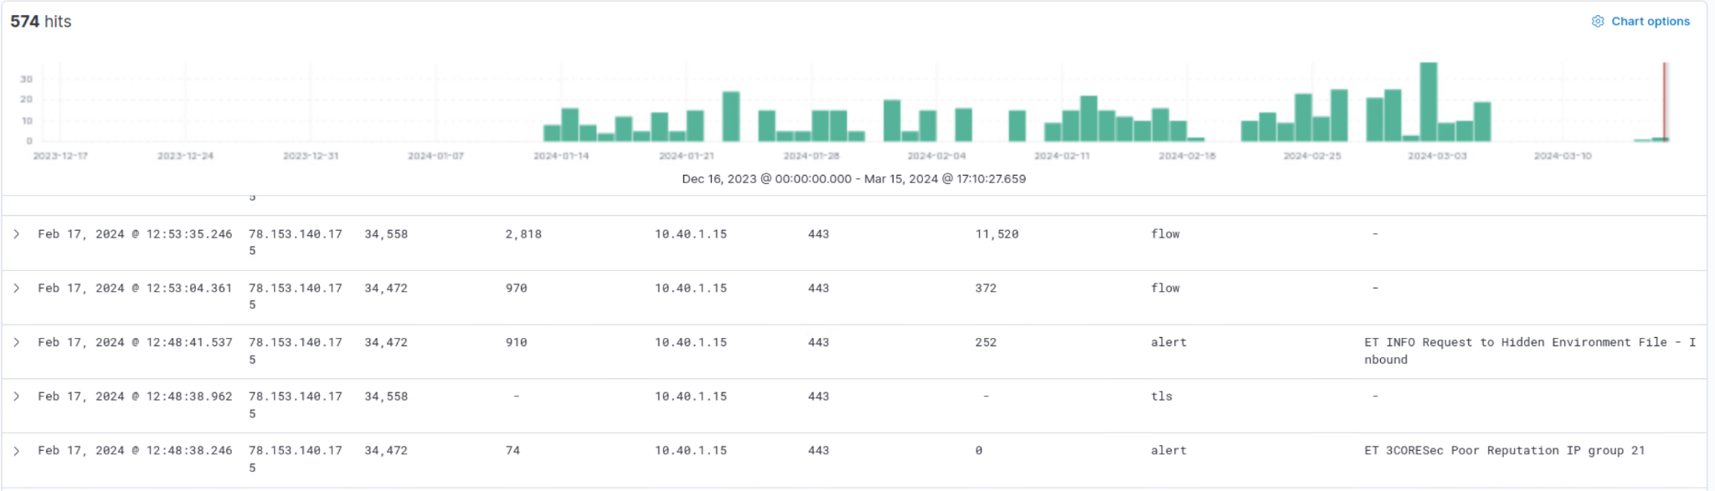Figure 1 - Shows the last 90 days of traffic where the source or destination is one of the known malicious IP. It shows the two different alerts that I mentioned, along with the flow events that still occurred after the alerts.

Geolocation connection security

-Alerts from sources outside the country is a common theme among Suricata.
- Threat huntings could always result in finding these geolocation threats
- Some threats seem small enough that it flies under the radar and is attempted again

Summary and Recommendation:

Threat hunting in elastic has yielded findings that show many attempted connections from hosts that seemed to be out of the country. While there were common connections from places like Canada, there were less trustful connections from places like Uruguay and China.
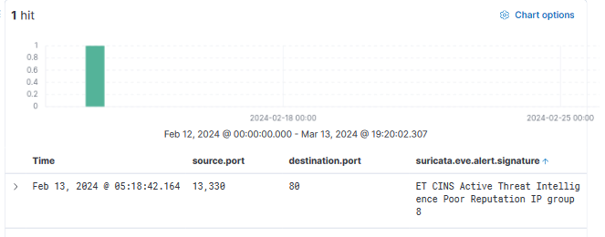
Figure 1 - A screenshot from Elastic of a reported connection attempt from China.
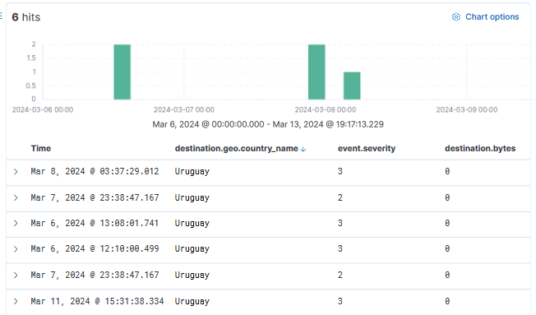
Figure 2 - A screenshot from Elastic of a week’s worth of attempted connection from Uruguay.

As a team we’ve hunted through thousands of alerts from Suricata. While there were many alarms that weren’t threatening to the network, there were always some attempted connections from out of the country. The Uruguay connections had been attempting to connect to the network for over 90 days, flooding Suricata with alerts and such.
While somewhat of a barrage of weak attacks, these connections are not scary on their own. They do; however, allow the attacker to gain information on how their attack was handled. We are aware there is a list of blocked countries, hostnames and IP’s for the network that is being built as threats are emerging. As a good practice recommendation, there should be a firewall on connections from countries that do not regularly interact with the network. This would allow for small scale attacks from out of the country to be mitigated with little effort before it even happens. While there are ways around this like making the attackers use a VPN, any way to make an attacker’s life a little harder is good for the network.

Organization-wide Phishing Awareness Training
- We caught multiple alerts for links being followed from phishing test emails by training vendors
- Vendor IP address and domain inventories could reduce false positives
- Because visibility is still useful, alerts should still be caught when traffic goes to these domains

Summary and Recommendation:

The observed influx of traffic to simulated phishing domains, such as "payments.crypto.us," underscores the critical importance of robust phishing mitigation strategies within organizational cybersecurity frameworks. While end users remain the first line of defense against phishing attacks, their susceptibility highlights the need for proactive measures. Phishing awareness training emerges as a fundamental component, enabling users to recognize and thwart phishing attempts by identifying red flags such as generic messages, poor grammar, unknown senders, suspicious links, and urgent language. Regular phishing simulation exercises serve as invaluable tools for assessing network readiness and refining incident response protocols. Reinforcing password security practices, including the adoption of strong and unique passwords, regular rotation, password managers, and multifactor authentication, further defends against credential theft and unauthorized access. By integrating these approaches, municipal network administration teams can cultivate a culture of vigilance, enhance employee resilience, and fortify their networks against the pervasive threat of phishing attacks.

Security/Web Vendor Scanning False Positives

- Extraordinary amounts of alerts were found to be generated by benign web scanning
- Multiple hours of threat hunting were dedicated to finding false positives
- False positives decrease efficiency for teams and increase blind spots

Summary and Recommendation:

Network monitoring sensors encountered numerous false positives attributed to routine web scanning activities, often conducted by web content scrapers or security vendors. These false positives stemmed from Suricata rules’ lack of precision in differentiating between benign web scans and malicious activities, leading to unnecessary alarms and remediation efforts. The primary challenge lies in distinguishing genuine malicious traffic from false positives, necessitating meticulous validation procedures similar to those employed during manual vulnerability testing. Optimizing Suricata rules is essential for minimizing false positives in network security monitoring. This can be achieved by tailoring rules to match the specific network environment and traffic patterns, avoiding overly broad rules that may trigger on benign activity. Additionally, regularly tuning and updating rules based on feedback from monitoring and analysis can help refine detection accuracy and reduce false positives. Utilizing Suricata's built-in features such as thresholding, flowbit manipulation, and custom rule creation allows for fine-tuning detection criteria to better align with the organization's security requirements and minimize unnecessary alerts.

